Posted 07/11/2012 at 8:50 am by JAV

Town Hall Building Committee

DRAFT Agenda
Town Hall Meeting Room
Friday July 13, 2012
9:00 AM

- Committee organization
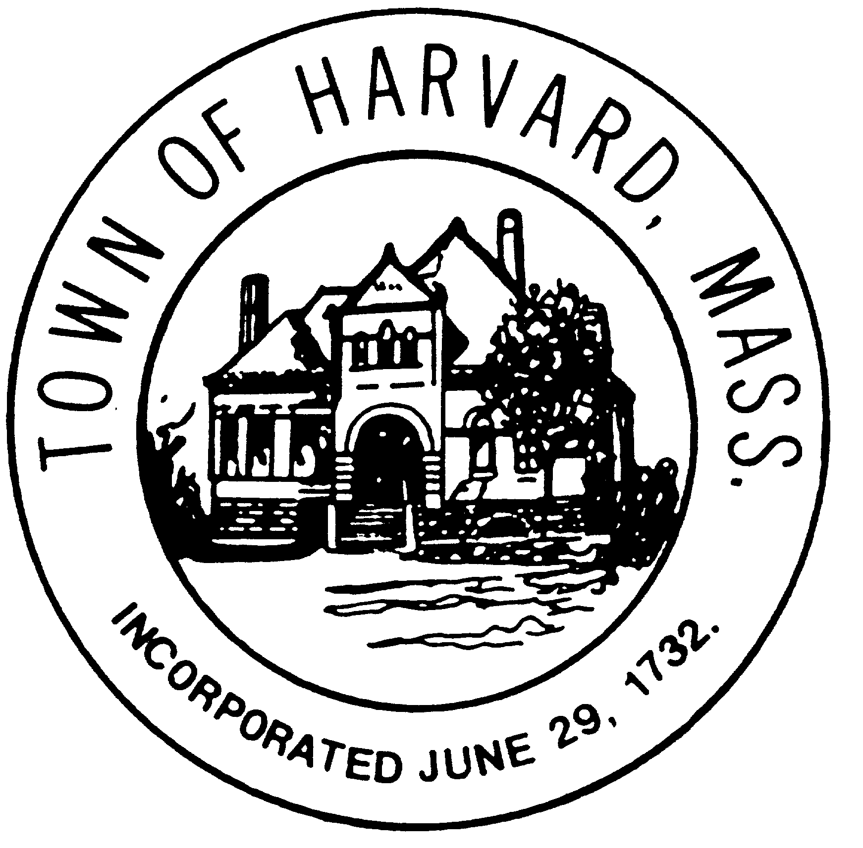
  - Chairmanship
  - Liaisons

- Approve minutes

- Approve invoices

- LLB DSB evaluation

- Discuss draft agreements with LLB and DTI

- Agenda and date for next meeting(s)

- New business

